**Spain Respiratory Devices Market**

According to Intelli, the Spain Respiratory Devices Market was valued at approximately USD 1,173.3 million in 2024 and is projected to reach USD 1624.24 million , growing at a compound annual growth rate (CAGR) of 5.05% during the forecast period of 2024-2032.

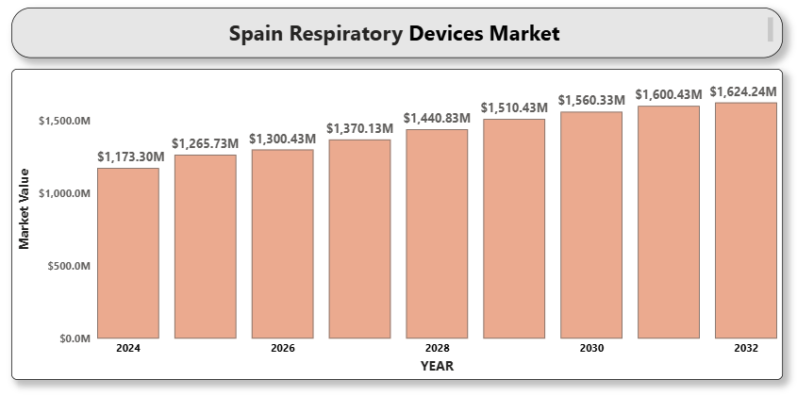

**Spain Respiratory Devices Market Definition**

Respiratory devices include diagnostic and therapeutic tools used for the prevention, diagnosis, and treatment of both acute and chronic pulmonary conditions. Common devices include nebulizers, inhalers, ventilators, oxygen concentrators, CPAP and BiPAP machines, humidifiers, and respiratory monitoring systems. In Spain, these devices play a critical role in managing chronic diseases, postoperative care, and intensive care treatment. These tools also support telemedicine and home healthcare initiatives, which are gaining popularity as the healthcare system moves toward value-based care and outpatient services.

**Spain Respiratory Devices Market Overview**

The respiratory devices market in Spain is experiencing a consistent rise in demand due to the growing aging population, increased awareness about respiratory illnesses, and enhanced access to medical treatment. Furthermore, the COVID-19 pandemic significantly accelerated the adoption of ventilators and oxygen delivery systems across hospitals and homecare settings. National health programs have focused on early diagnosis and long-term disease management, contributing to greater usage of diagnostic tools such as spirometers and peak flow meters. Meanwhile, the increasing preference for minimally invasive respiratory treatments and wearable monitoring devices is expanding the market’s reach beyond traditional hospital settings.

**Spain Respiratory Devices Market Segmentation Analysis**

The Spain Respiratory Devices Market is segmented based on Product Type, Application, End-user, and Region. This segmentation provides a comprehensive understanding of demand distribution and market potential across multiple categories.

**Spain Respiratory Devices Market By Product Type**

Key product segments include:

* **Therapeutic Devices**: Inhalers, nebulizers, ventilators, CPAP and BiPAP devices, oxygen concentrators.
* **Monitoring Devices**: Capnographs, pulse oximeters, respiratory rate monitors.
* **Diagnostic Devices**: Spirometers, peak flow meters, polysomnography devices. Among these, inhalers and oxygen concentrators account for the largest share due to their routine use in managing asthma, COPD, and respiratory distress syndromes. The demand for ventilators has also grown, especially for critical care settings, influenced by COVID-19 and the increasing number of ICU admissions.

**Spain Respiratory Devices Market By Application**

Major applications include:

* **Asthma**: Inhalers and nebulizers are frequently prescribed to manage bronchial constriction.
* **COPD**: Oxygen therapy and non-invasive ventilators are widely adopted.
* **Sleep Apnea**: CPAP and BiPAP machines are key therapeutic tools.
* **Infectious Diseases**: Ventilators and humidifiers assist in respiratory support for pneumonia and post-COVID complications. COPD remains the most dominant application segment, driven by its increasing prevalence among the aging population and smokers. Furthermore, sleep apnea is gaining attention due to greater awareness of its impact on overall health and productivity, resulting in wider adoption of sleep diagnostic and therapy devices.

**Spain Respiratory Devices Market By End-user**

End-users include:

* **Hospitals**: Largest consumers of high-end diagnostic and therapeutic equipment.
* **Homecare Settings**: Rapidly growing due to cost-efficiency and patient comfort.
* **Clinics**: Often use portable diagnostic tools for preliminary assessment.
* **A close-up of hands holding a tablet and a pen

  Description automatically generatedAmbulatory Centers**: Provide short-term respiratory treatments and outpatient services. Hospitals dominate due to their comprehensive infrastructure, but there is a noticeable shift toward home-based respiratory management to minimize hospitalization costs and provide chronic care in familiar environments. Homecare settings are projected to experience the fastest growth over the forecast period.

**Spain Respiratory Devices Market, By Region**

Key regions analyzed include:

* **Madrid**: High market share due to advanced healthcare infrastructure and research institutions.
* **Barcelona**: A leader in healthcare innovation and private-public medical collaboration.
* **Valencia**: A growing hub for medical device distribution.
* **Andalusia**: Emerging market with increasing adoption in rural and semi-urban centers.
* **Rest of Spain**: Includes Basque Country, Galicia, and others with varying levels of device penetration. Madrid and Barcelona account for the bulk of demand due to their concentration of tertiary hospitals, research facilities, and early technology adoption.

**Key Players**

Notable players in the Spain Respiratory Devices Market include:

* **Philips Healthcare**: Offers a wide range of oxygen therapy and monitoring solutions.
* **ResMed**: Specializes in sleep apnea therapy devices and cloud-connected CPAP machines.
* **Medtronic**: Provides invasive and non-invasive ventilators along with respiratory monitoring equipment.
* **GE Healthcare**: Known for high-performance anesthesia and ventilation systems.
* **Fisher & Paykel Healthcare**: Offers respiratory humidification systems widely used in ICUs and homecare. These companies maintain a strong presence in the Spanish market through distribution partnerships, technology innovation, and participation in national health procurement initiatives.

**Key Developments**

* **In March 2024**, Philips Healthcare introduced its advanced intelligent ventilation systems, designed to enhance respiratory care through adaptive, patient-specific support. These systems integrate AI-driven algorithms to automatically adjust ventilation parameters in real time, improving patient outcomes and reducing the workload on healthcare professionals.
* **In May 2024**, ResMed launched innovative home respiratory monitoring solutions aimed at improving the management of chronic respiratory conditions such as COPD and sleep apnea. These solutions leverage connected technology and real-time data tracking to enable remote patient monitoring, early intervention, and enhanced treatment adherence.
* **In April 2024**, Medtronic expanded its respiratory care portfolio by launching the VitalFlow™ Extracorporeal Membrane Oxygenation (ECMO) system. This innovative, configurable ECMO solution is designed to simplify critical care delivery, offering seamless integration between bedside management and intra-hospital transport.

**Market Attractiveness**

Spain presents an attractive market landscape due to several factors:

* **Aging Population**: Increases demand for chronic disease management tools.
* **Government Support**: Subsidized healthcare access and strategic investments in medical technology.
* **Homecare Adoption**: Growing preference for at-home respiratory treatment supported by telemedicine.
* **R&D Initiatives**: Collaborations between academic institutions and industry players to develop user-friendly, digital respiratory solutions. Together, these elements make Spain a fertile ground for long-term growth in respiratory care.

**Porter’s Five Forces**

* **Threat of New Entrants**: Moderate. The market is regulated but open to innovation-driven newcomers.
* **Bargaining Power of Suppliers**: Moderate to High. Specialized components and limited vendors can influence supply chain pricing.
* **Bargaining Power of Buyers**: High. Public hospitals and government tenders hold significant procurement power.
* **A close-up of hands holding a tablet and a pen

  Description automatically generatedThreat of Substitutes**: Low. Few alternative treatments offer the effectiveness and immediacy of respiratory devices.
* **Industry Rivalry**: High. Competitive pressure exists due to rapid technological evolution and pricing competition.

**TABLE OF CONTENT**

1. **INTRODUCTION OF SPAIN RESPIRATORY DEVICES MARKET**

1.1 Overview of the Market

1.2 Scope of Report

1.3 Assumptions

1. **EXECUTIVE SUMMARY**
2. **RESEARCH METHODOLOGY**

3.1 Data Mining

3.2 Validation

3.3 Primary Interviews

3.4 List of Data Sources

1. **SPAIN RESPIRATORY DEVICES MARKET OUTLOOK**

4.1 Overview

4.2 Market Dynamics

4.3 Drivers

4.4 Restraints

4.5 Opportunities

4.6 Trends

4.7 Porter’s Five Force Model

4.8 Value Chain Analysis

1. **SPAIN RESPIRATORY DEVICES MARKET, BY PRODUCT TYPE**

5.1 Therapeutic Devices

5.2 Monitoring Devices

5.3 Diagnostic Devices

1. **SPAIN RESPIRATORY DEVICES MARKET, BY APPLICATION**

6.1 Asthma

6.2 COPD

6.3 Sleep Apnea

6.4 Infectious Diseases

1. **SPAIN RESPIRATORY DEVICES MARKET, BY END-USER**

7.1 Hospitals

7.2 Homecare Settings

7.3 Clinics

7.4 Ambulatory Centers

1. **SPAIN RESPIRATORY DEVICES MARKET, BY REGION**

8.1 Madrid

8.2 Barcelona

8.3 Valencia

8.4 Andalusia

8.5 Rest of Spain

1. **SPAIN RESPIRATORY DEVICES MARKET COMPETITIVE LANDSCAPE**

9.1 Company Market Ranking

9.2 Key Development Strategies

1. **COMPANY PROFILES**

**10.1 Philips Healthcare**

1. Overview
2. Financial Performance
3. Product Outlook
4. Key Developments

**10.2 ResMed**

1. Overview
2. Financial Performance
3. Product Outlook
4. Key Developments

**10.3 Medtronic**

1. Overview
2. Financial Performance
3. Product Outlook
4. Key Developments

**10.4 GE Healthcare**

1. Overview
2. Financial Performance
3. Product Outlook
4. Key Developments

**10.5 Fisher & Paykel Healthcare**

1. A close-up of hands holding a tablet and a pen

   Description automatically generatedOverview
2. Financial Performance
3. Product Outlook
4. Key Developments
5. **KEY DEVELOPMENTS**

11.1 Product Launches/Developments

11.2 Mergers and Acquisitions

11.3 Business Expansions

11.4 Partnerships and Collaborations

1. **APPENDIX**

12.1 Related Research